|  |  |
| --- | --- |
| **PROJECT** | **MS Project 2016 En** |
| **REPORT NO** | **20180215-PM-01 MS Project 2016 Create A New Plan** |
| **SUBJECT** | **Tutorial about GANTT - creating plan and schedule of tasks/activities with software tool MicroSoft Project 2016** |
| **AUTHOR** | **Nedim Basic** |
| **LOCATION** |  |
| **CREATION DATE** | **15.02.2018.** |
| **PICTURE DATE IF EXIST** |  |
| **SECURITY LEVEL** |  |
| File Name |  |
| ﻿ Attachments |  |
| Related Documents |  |
| Number of Pages (Including this page) |  |



©2013 **Nedim Basic**

This document contains proprietary and confidential information of „**Nedim Basic**“ and shall not be reproduced or transferred to other documents, disclosed to others, or used for any purpose other than that for which it is furnished, without the prior written consent of „**Nedim Basic**“. It shall be returned to the respective „**Nedim Basic**“ companies upon request.

The trademark and service marks of „**Nedim Basic**“, including the „**Nedim Basic**“ mark and logo, are the exclusive property of „**Nedim Basic**“, and may not be used without permission. All other marks mentioned in this material are the property of their respective owners.

# Document control

# Edits

|  |  |  |  |
| --- | --- | --- | --- |
| **Date** | **Author** | **Version** | **Comment** |
| 15.02.2018. | Nedim Basic |  |  |
|  |  |  |  |

# Responsible persons

|  |  |  |
| --- | --- | --- |
| **Name** | **Position** | **Comment** |
| Nedim Basic | Project and System Engineer |  |

Contents

Document control 1

Edits 1

Responsible persons 2

Launch MS Project 4

Create Blank Project 4

Project Information 5

Step 1 − Start Date 5

Step 2 − Set Up Calendar 5

Step 3 − Adding Exceptions to Calendar 6

Step 4 − Setting up Resource Calendar 7

Step 5 − Change Working times for Each Resource 8

Step 6 − Create Non-working Days 9

Change File Properties 10

Step 1 − Launch MS Project 10

Step 2 − Save Properties 10

Build Task List 11

Enter Task 11

Enter Duration 12

Change Default Time Dimensions 13

Enter Task Duration 14

Elapsed Duration 15

Create Milestones 17

Method 1 − Inserting a Milestone 17

Method 2 − Converting a Task to a Milestone 17

Method 3 − Converting a Task to a Milestone 17

Make Project Summary Task visible 18

Create Summary Task 18

Method 1 19

Method 2 19

Link Tasks 19

Method 1 20

Method 2 21

Method 3 22

Respect Links 22

Switching Task – Manual to Automatic 24

Converting Task to Automatic Schedule 24

Method 1 24

Method 2 25

Method 3 25

When working with MS Project you either specify a start date or a finish date. Because once you enter one of the two, and other project tasks, constraints and dependencies, MS Project will calculate the other date. It is always a good practice to use a start date even if you know the deadline for the project.

# Launch MS Project

* **Windows 7** − Click on Start menu, point to All Programs, click Microsoft Office, and then click Project 2013.
* **Windows 8** − On the Start screen, tap or click Project 2013.
* **Windows 10** − Click on Start menu → All apps → Microsoft Office → Project 2013.

# Create Blank Project

MS Project 2016 will display a list of options. In the list of available templates, click **Blank Project**.

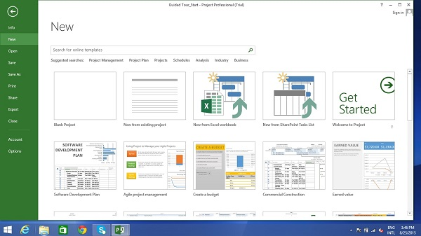

Project sets the plan’s start date to current date, a thin green vertical line in the chart portion of the Gantt Chart View indicates this current date.

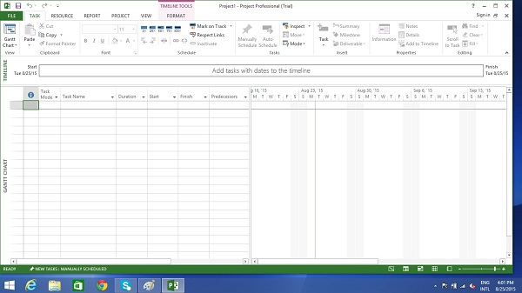

# Project Information

Let us change the project start date and add some more information.

## Step 1 − Start Date

Click Project tab → Properties Group → Project Information.

A dialog box appears. In the start date box, type 11/5/15, or click the down arrow to display the calendar, select November 5, 2015 (or any date of your choice).

Click OK to accept the start date.

## Step 2 − Set Up Calendar

Click Project tab → Properties Group → Project Information.

Click the arrow on the Current Date dropdown box. A list appears containing three base calendars.

* **24 Hour** − A calendar with no non-working time.
* **Night Shift** − Covers 11 PM to 8 AM, night shifts covering all nights from Monday to Friday, with one hour breaks.
* **Standard** − Regular working hours, Monday to Friday between 8 AM to 5 PM, with one hour breaks.

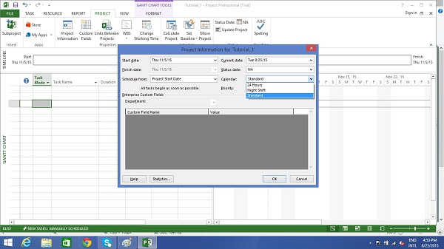

Select a Standard Calendar as your project Calendar. Click “Cancel” or “OK” to close the dialog box.

Now let us add exceptions.

## Step 3 − Adding Exceptions to Calendar

Exceptions are used to modify a Project calendar to have a non-standard workday or a non-working day. You can also allot unique working hours for a particular resource as well.

Here is an example to create a non-working day, which could be because of a holiday or office celebrations or events other than the standard office work effort.

Click Project tab → Properties Group → Change Working Time.

**Change Working Time** dialog box appears. Under Exceptions Tab click on the Name Field, enter event as “Office Anniversary”. In the Start field enter 11/22/15, and then enter the same date in the Finish field. This date is now scheduled as a non-working day for the project. You can also verify the changed color indicated in the calendar within the dialog box as below. Click Ok to close.

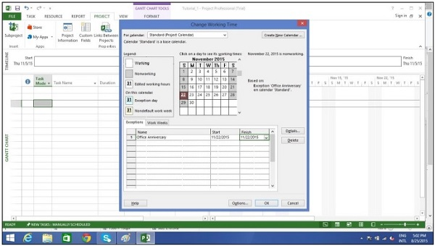

## Step 4 − Setting up Resource Calendar

Just like you can change a **Standard Base Calendar**, you can change the work and non-working time for each resource. You can modify the resource calendar to accommodate flex-time, vacation time, training time, etc.

Also remember, **Resource Calendar** can only be applied to work resources and not to material and cost resources.

By default when we create the resources in a plan, the resource calendar matches the **Standard base calendar**. And any changes you make to the Project Calendar, gets reflected automatically in resource calendars, except when you create an exception in the resource calendar. In that case even if you update the project calendar, the exception in resource calendar is not affected.

Click Project tab → Properties group → Click Change Working Time

Change Working Time dialog box appears.

Click the down arrow for the “For Calendar” drop-down box.

Select the resource for whom you want to create an exception. In example below I have chosen John.

Under Exceptions Tab click on the **Name** Field, enter event as “Personal holiday”. In the **Start** field enter the date (example 9/15/2015), and then enter the same date in the **Finish** field.

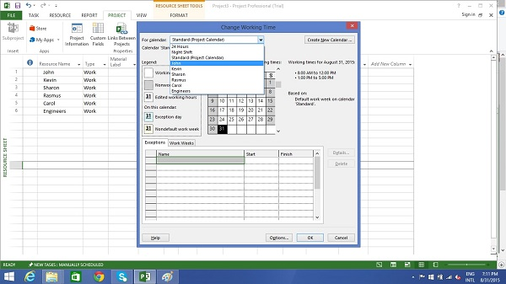

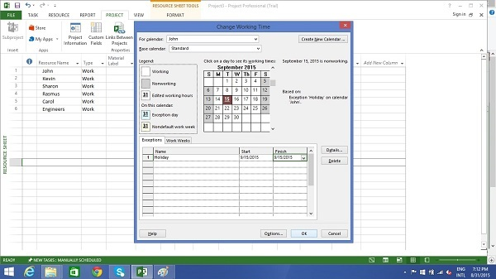

## Step 5 − Change Working times for Each Resource

Click Project tab → Properties group → Click Change Working Time.

The Change Working Time dialog box appears.

Click the down arrow for the “For Calendar” dropdown box.

Select the resource for whom you want to change work schedule. In the

following screen you can see we have chosen John.

Click “Work Weeks” tab.

Double-click the [default] cell below the Name column heading.

Under “Selected Day(s)” choose any day you want to change the work schedule.

We have chosen Tuesday and Wednesday.

Click Set day(s) to these specific working times. Change the time.

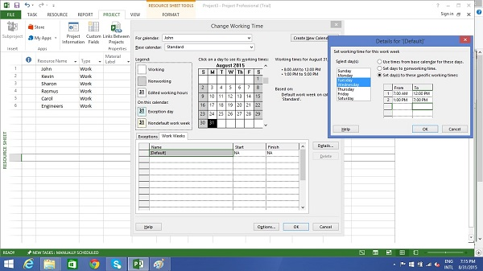

## Step 6 − Create Non-working Days

Click Project tab → Properties group → Click Change Working Time.

The Change Working Time dialog box appears.

Click the down arrow for the “For Calendar” dropdown box.

Select the resource for whom you want to change work schedule. We have chosen John again.

Click “Work Weeks” tab.

Double-click the [default] cell below the Name column heading.

Under “Selected Day(s)” choose any day you want to change the work schedule.

Click any day (we have chosen Friday) and use the radio button “Set days to nonworking time”.

Click OK to close the Dialog box. You will now see all Fridays are greyed out in the calendar.

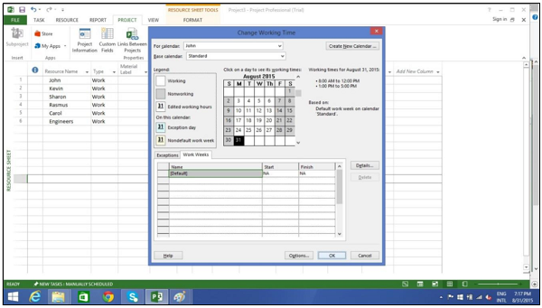

# Change File Properties

With Microsoft Windows Operating system, right clicking a file and selecting “Properties” brings up the file properties dialog box that contains version, security and other file details. You can record some top level information for your .mpp project file as well. This can be done as follows −

# Step 1 − Launch MS Project

* **Windows 7** − Click on Start menu, point to All Programs, click Microsoft Office, and then click Project 2013.
* **Windows 8** − On the Start screen, tap or click Project 2013.
* **Windows 10** − Click on Start menu → All apps → Microsoft Office → Project 2013.

# Step 2 − Save Properties

Click File Tab. Under Info Tab go to Project Information. Click arrow near Project Information to click Advanced Properties. A dialog box opens, you can type in the changes as required. Click OK and don’t forget to save by clicking on Save.

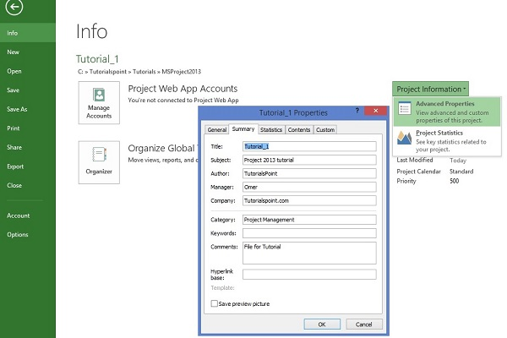

# Build Task List

Before we start, let us assume you already have a Work Breakdown Structure (WBS). In context of WBS, “Work” refers to “Deliverables” and not effort.

WBS identifies the deliverable at the lowest level as work package. This work package is decomposed into smaller tasks/activities, which is the effort necessary to complete the work package. So a task is action-oriented, and the work package is the deliverable or a result of one or more tasks being performed.

There is a significant amount of confusion between what constitutes an activity and what constitutes a task within the project management community. But for MS Project, a task is the effort and action required to produce a particular project deliverable. MS Project does not use the term “activity”.

# Enter Task

This is simple. In **Gantt Chart** View, just click a cell directly below the Task Name column. Enter the task name. In the following screen, we have entered 5 different tasks.

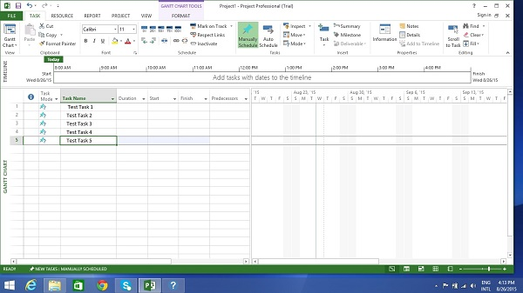

# Enter Duration

A duration of the task is the estimated amount of time it will take to complete a task. As a project manager you can estimate a task duration using expert judgment, historical information, analogous estimates or parametric estimates.

You can enter task duration in terms of different dimensional units of time, namely minutes, hours, days, weeks, and months. You can use abbreviations for simplicity and ease as shown in the following table.

|  |  |  |
| --- | --- | --- |
| **Value you want to enter** | **Abbreviation** | **Appearance** |
| 45 minutes | 45 m | 45 mins |
| 2 hours | 2h | 2 hrs |
| 3 days | 3d | 3 days |
| 6 weeks | 6w | 6 weeks |
| 2 months | 2mo | 2 mons |

Remember, Project default values depend on your work hours. So 1 day is not equivalent to 24 hours but has 8 hours of work for the day. Of course, you can change these defaults anytime you want.

|  |  |  |
| --- | --- | --- |
| **Value entered** | **Value** | **Project default Value** |
| 1 minute | 60 seconds | 60 seconds |
| 1 hour | 60 minutes | 60 minutes |
| 1 day | 24 hours | 8 hours (1 workday) |
| 1 week | 7 days | 40 hours (5 workdays) |
| 1 month | 28 to 31 days | 160 hours (20 workdays) |

# Change Default Time Dimensions

Click Project tab → Properties Group → Click Change Working Time → Click Options.

You can apply this to all projects or a specific project that you are working on currently.

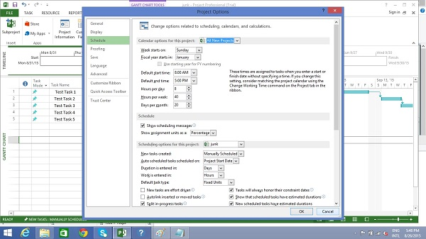

One of the neat tricks MS Project possesses is, it considers duration of the task in workday sense. So if you have a non-working day in between, it accommodates this and ensures a task that takes 16 hours to complete to end on the 3rd day. In other words, if you have a task that needs 16 hours to complete starting on Monday 8:00 AM (if this is the time your work day starts, and 8 hours being total work hours in a day), and Tuesday being a holiday, the task will logically end on the evening of Wednesday.

**Tip** − With manually scheduled tasks, if you are not sure about a task duration, you can just enter text such as “Check with Manager/Engineer” to come back to this later.

# Enter Task Duration

This is simple in **Gantt Chart** View, click the cell below Duration column heading. Enter the duration. (Task 1 in the following screenshot)

You can also enter Start and Finish date and MS Project will calculate the duration on its own. (Task 2 in the following screenshot)

You can enter text as well when you don’t have a duration metric currently. (Task 3 and Task 4 in the following screenshot)

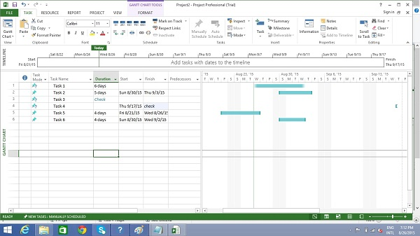

**Note** − In the above screenshot, Task 6 is scheduled to start on Sunday, which is a nonworking day and ends on Wednesday. So essentially, one would believe that with these 3 days Monday, Tuesday, Wednesday, the duration calculated would be 3 days. But MS Project 2016 calculates it as 4 days. So one needs to be careful when choosing the start date of the task. Because for any successive operation, MS Project 2016 considers that Task 6 will take 4 days. The next time, you change the start date, the Finish date changes to reflect this 4-day duration.

# Elapsed Duration

Elapsed Duration is the time that elapses while some event is occurring which does not require any resources. Elapsed duration for a task can be used in instances where a task will go on round-the-clock without any stoppage. A normal workday has 8 hours, and an elapsed day duration will have 24 hours. The task also continues over non-working (holidays and vacations) and working days.

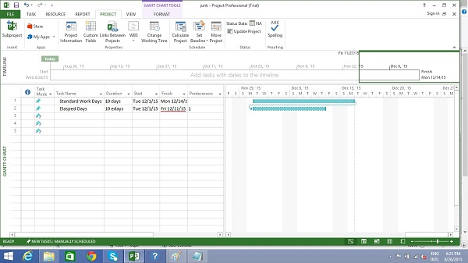

You can enter elapsed duration by preceding any duration abbreviation with an “e”. So 1ew is seven 24-hour days.

For example, when you are ‘Waiting for the paint to dry’. And it takes 4 days for this to happen. It does not need a resource or a work effort, and all you are doing is waiting for it to dry. You can use 4ed as the time duration, which signifies 4 elapsed days, the paint can dry regardless of whether it is a weekend or if it falls on a holiday. Here in this example, the drying occurs over 24 hours over the weekend.

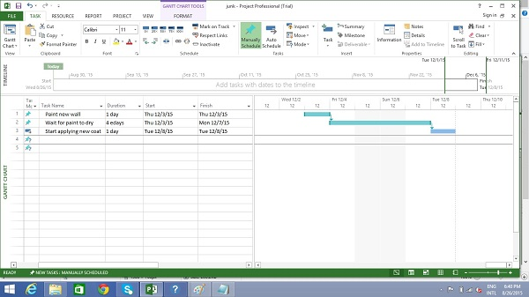

# Create Milestones

In Project Management, Milestones are specific points in a project timeline. They are used as major progress points to manage project success and stakeholder expectations. They are primarily used for review, inputs and budgets.

Mathematically, a milestone is a task of zero duration. And they can be put where there is a logical conclusion of a phase of work, or at deadlines imposed by the project plan.

There are two ways you can insert a milestone.

## Method 1 − Inserting a Milestone

Click name of the Task which you want to insert a Milestone

Click Task tab → Insert group → Click Milestone.

MS Project names the new task as <New Milestone> with zero-day duration.

Click on <New Milestone> to change its name.

You can see the milestone appear with a rhombus symbol in the Gantt Chart View on the right.

## Method 2 − Converting a Task to a Milestone

Click on any particular task or type in a new task under the **Task Name** Heading.

Under **Duration** heading type in “0 days “.

MS Project converts it to a Milestone.

## Method 3 − Converting a Task to a Milestone

In Method 2, a task was converted to a Milestone of Zero duration. But one can also convert a task of non-zero duration into a Milestone. This is rarely used and causes confusion.

Double-click a particular Task name.

Task Information dialog box opens.

Click Advanced tab → select option “Mark Task as Milestone”.

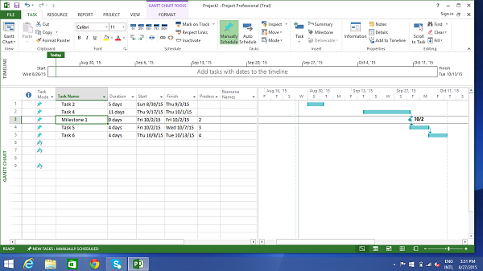

# Make Project Summary Task visible

The project summary task summarizes your whole project.

In Gantt Chart View → Format Tab → Show/Hide → click to check Project Summary Task on.

# Create Summary Task

There can be a huge number of tasks in a project schedule, it is therefore a good idea to have a bunch of related tasks rolled up into a **Summary Task** to help you organize the plan in a better way. It helps you organize your plan into phases.

In MS Project 2016, you can have several number of sub-tasks under any higher level task. These higher level tasks are called Summary Task. At an even higher level, they are called **Phases**. The highest level of a plan’s outline structure is called the **Project Summary Task**, which encompasses the entire project schedule.

Remember because summary task is not a separate task entity but a phase of the project with several sub-tasks in it, the duration of the summary task is from the start of the first sub-task to the finish of the last sub-task. This will be automatically calculated by MS Project.

Of course, you can enter a manual duration of the summary task as well which could be different from the automatically calculated duration. MS Project will keep track of both but this can cause significant confusion.

In most cases, you should ensure that there is no manually entered duration for any task you will be using as a Summary Task.

Let us use the following screenshot as an example. If you would like to group Task 4 and Task 5 into a Summary Task 1. You can do it in two ways.

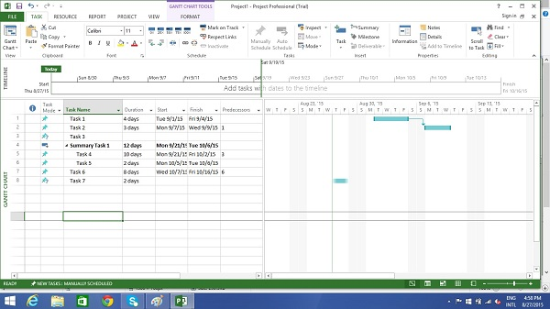

## Method 1

Select the names of Task 4 and Task 5.

Click **Task** Tab → group **Insert** → Click **Summary**

MS Project creates a <New Summary Task>.

Rename it to Summary Task 1.

## Method 2

You can click Task 4 row.

Select “Insert Task”. A <New Task> is created.

You can rename the Task. Here it is renamed as Summary Task 1. Don’t enter any duration for this task.

Now select Task 4 and Task 5.

Click **Task** tab → **Schedule** group → Click **Indent** Task

# Link Tasks

Once you have a list of tasks ready to accomplish your project objectives, you need to link them with their task relationships called dependencies. For example, Task 2 can start once Task 1 has finished. These dependencies are called Links. **A Guide to the Project Management Body of Knowledge (PMBOK Guide)** does not define the term dependency, but refers to it as a logical relationship, which in turn is defined as a dependency between two activities, or between an activity and a milestone.

In MS Project, the first task is called a **predecessor** because it precedes tasks that depend on it. The following task is called the **successor** because it succeeds, or follows tasks on which it is dependent. Any task can be a predecessor for one or more successor tasks. Likewise, any task can be a successor to one or more predecessor tasks.

There are only four types of task dependencies, here we present them with examples.

* **Finish to Start** (FS) − Finish the first floor before starting to build the second floor. Most used.
* **Finish to Finish** (FF) − Cooking all dishes for dinner to finish on time.
* **Start To Start** (SS) − When doing a survey, we would seek survey responses but will also start tabulating the responses. One does not have to finish collecting survey response before starting the tabulation.
* **Start to Finish** (SF) − Exam preparation will end when exam begins. Least used.

In MS Project you can identify the Task Links −

* **Gantt Chart** − In Gantt Chart and **Network Diagram** views, task relationships appear as the links connecting tasks.
* **Tables** − In Tables, task ID numbers of predecessor task appear in the predecessor fields of successor tasks.

## Method 1

Select the two tasks you want to link. In the following screenshot taken as an example, we have selected names, Task 1 and Task 2.

Click Task tab → Schedule group → Link the Selected Tasks.

Task 1 and Task 2 are linked with a Finish-to-Start relationship.

**Note** − Task 2 will have a Start date of the Next working day from Finish date of Task 1.

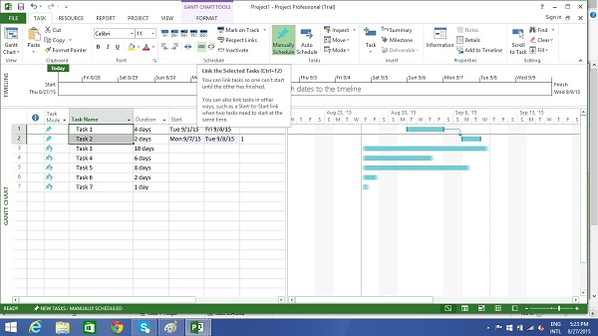

## Method 2

Double click a successor task you would like to link.

Here I have clicked Task 4

The Task information dialog box opens

Click Predecessors tab

In the Table, click the empty cell below Task Name column.

A drop down box appears with all Tasks defined in the project.

Choose the predecessor task. Click **OK**.

Here I have chosen Task 3.

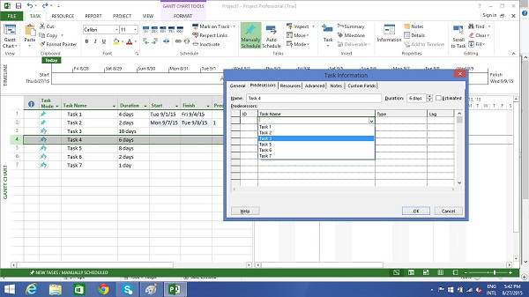

## Method 3

In this method, you will select a group of task, and link them all with Finish-to-Start relationship.

Select multiple tasks with the help of the mouse → Task tab

→ Schedule group → Link the Selected Tasks.

All tasks get linked. To select non-adjacent tasks, hold down Ctrl key and select each task separately.

# Respect Links

If you are in Manually Scheduled mode, any change in duration of the predecessor task will not reflect on Start date of Task 4. For example, Task 4 starts on 9/3/15 which is the next day of Finish date of Task 3.

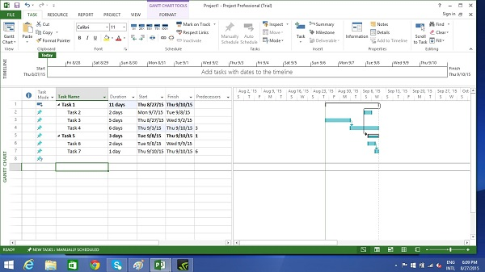

Now when we change the Duration of Task 3 from 5 to 7 days, the start date is not automatically updated for Task 4 in Manual Scheduling.

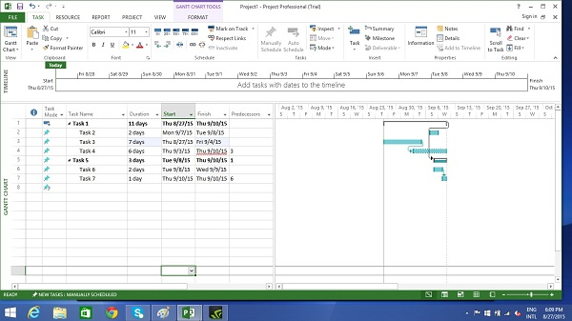

You can force MS Project to respect the link (dependency) by doing the following −

* Select Task 4.
* Click Task tab → Schedule group → Respect Links.

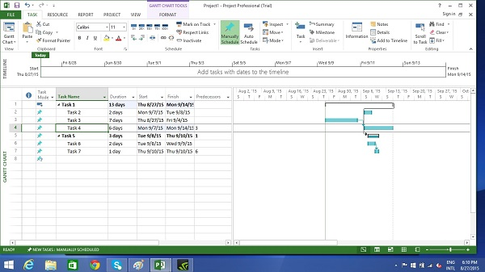

# Switching Task – Manual to Automatic

MS Project by default sets new tasks to be manually scheduled. Scheduling is controlled in two ways.

**Manual Scheduling** − This is done to quickly capture some details without actually scheduling the tasks. You can leave out details for some of the tasks with respect to duration, start and finish dates, if you don’t know them yet.

**Automatic Scheduling** − This uses the Scheduling engine in MS Project. It calculates values such as task durations, start dates, and finish dates automatically. It takes into accounts all constraints, links and calendars.

For example, at Lucerne Publishing, the new book launch plan has been reviewed by the resources who will carry out the work and by other project stakeholders. Although you expect the plan to change somewhat as you learn more about the book launch, you now have enough confidence in the overall plan to switch from manual to automatic task scheduling.

# Converting Task to Automatic Schedule

We have three different methods to convert a task to automatic schedule.

## Method 1

If you want to change the mode for a particular task, say Task 5 in the following example. Click on **Task Mode** cell in the same row. Then, click the down arrow to open a dropdown box, you can select Auto Scheduled.

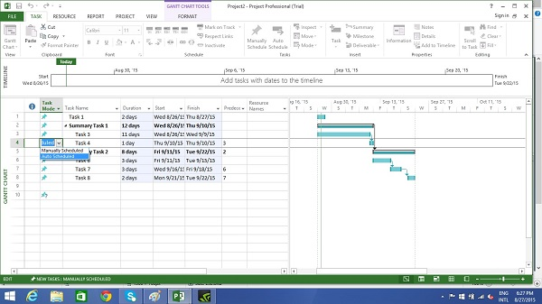

## Method 2

Click Task → Tasks group → Auto Schedule.

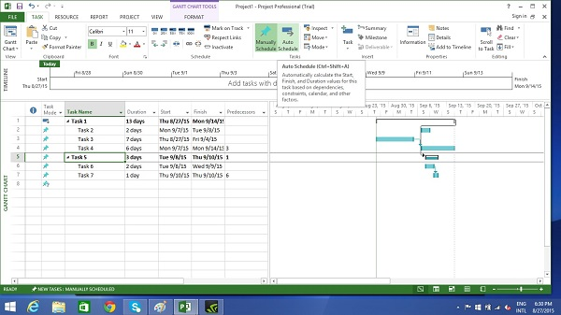

## Method 3

To switch completely to Auto Schedule mode −

Toggle the scheduling mode of the plan by clicking the New Tasks status bar (at the bottom-left) and then selecting Auto scheduling mode.

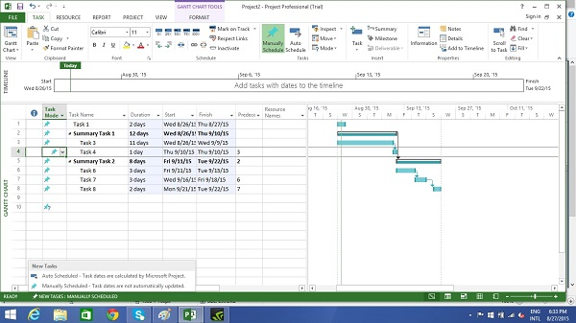

You can also change the default scheduling mode that Project applies to all new plans.

Go to File tab and click Options. Then click Schedule tab and under scheduling options for this project select “All New Projects” from the dropdown box. Under new tasks created, select “Auto Scheduled” from the dropdown box.

